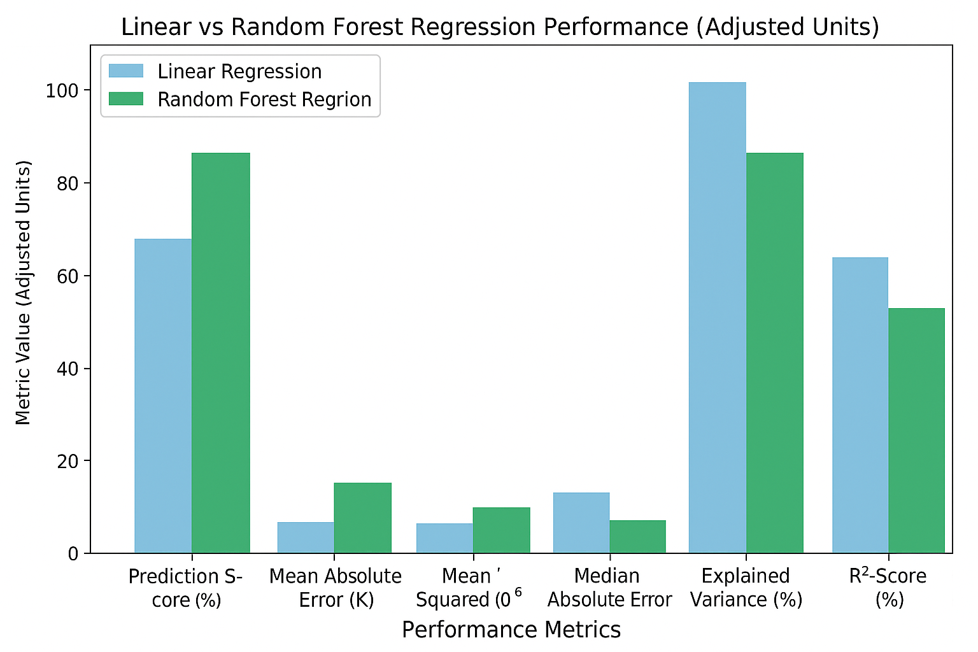

**Higher Accuracy:**

Random Forest achieved a **prediction score of 95.79%**, while Linear Regression only reached **66.87%**.

This means Random Forest predicts target values much closer to actual results.

**Lower Errors:**

The **Mean Absolute Error (4,749)** and **Mean Squared Error (119M)** are significantly lower than Linear Regression’s **24,404** and **938M**, showing that Random Forest’s predictions are much more precise.

**Handles Non-Linear Relationships:**

Linear Regression assumes a straight-line (linear) relationship between variables.

Random Forest, however, captures **complex, non-linear patterns**, making it ideal for real-world data.

**Better Variance and R² Scores:**

With an **Explained Variance** and **R² score of 0.96**, Random Forest explains almost all the variability in the data, compared to only **0.67** for Linear Regression.

**More Robust:**

Random Forest is resistant to **outliers**, **multicollinearity**, and **overfitting**, since it combines predictions from multiple trees.